# p234 二、程序练习 2

#include<iostream>

using namespace std;

class student

{

Private:

char name[20];

unsigned int id;

double score;

public:

void input(student &stu)

{

cout << "name?";

cin >> stu.name;

cout << "id?";

cin >> stu.id;

cout << "score?";

cin >> stu.score;

};

void output(student &stu)

{

cout << "name:" << stu.name << "\tid:" << stu.id << "\tscore:" << stu.score << endl;

};

};

int main()

{

student s;

s.input(s);

s.output(s);

}

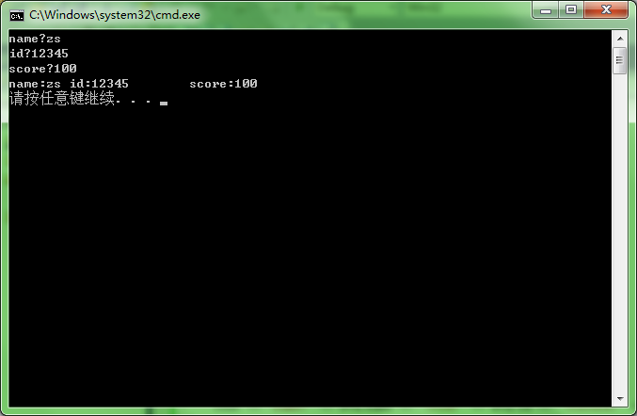

# p242 二、程序练习 1.

#include<iostream>

using namespace std;

class Book

{

char bookname[20];

double price;

int number;

public:

void getBook(char*nam, double pri, int num)

{

strcpy_s(bookname, nam);

price = pri;

number = num;

};

void borrow()

{

if (number == 0)

cout << "该书以无库存！" << endl;

number = number - 1;

};

void restore()

{

++number;

};

void display()

{

cout << "图书情况:"<<"\nbookname:" << bookname << "\nprice:" << price << "\nnumber:" << number << endl;

};

};

int main()

{

char a, b;

Book cpp;

cpp.getBook("C++程序设计基础", 50, 200);

cpp.display();

a = 'y';

while (a == 'y')

{

cout << "请输入操作：借出(b)/归还(r)" << endl;

cin >> b;

switch (b)

{

case 'b':cpp.borrow();break;

case 'r':cpp.restore();

}

cout << "请输入操作：继续(y)/退出(n)" << endl;

cin >> a;

}

cpp.display();

} 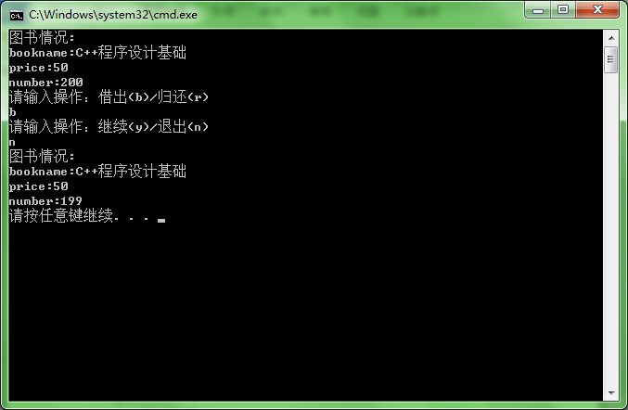 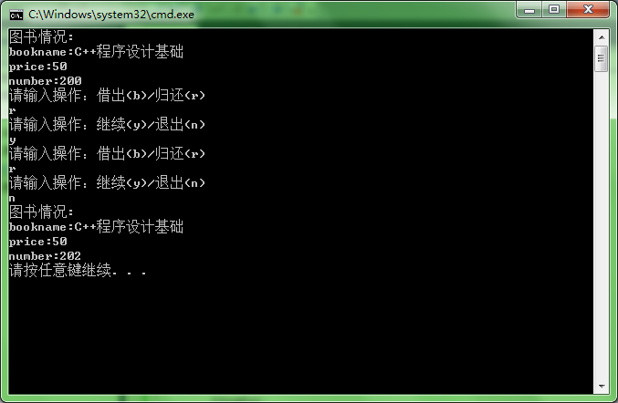

# p242 二、程序练习 3.

#include<iostream>

using namespace std;

class student

{

public:

void scoretotalcount(double s)

{

score = s;

total += score;

count++;

}

static double sum()

{

return total;

}

static double average()

{

return total / count;

}

private:

double score;

static double total;

static int count;

};

double student::total = 0;

int student::count = 0;

int main()

{

double s;

int n ;

student stu;

cout << "人数" << endl;

cin >> n;

for (int i = 1;i <= n;i++)

{

cout << "输入第" << i << "名的成绩:" << endl;

cin >> s;

stu.scoretotalcount(s);

}

cout << "总分:" << stu.sum ()<< endl;

cout << "平均分：" << stu.average() << endl;

}

